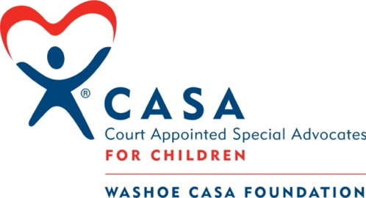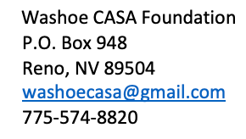

BOARD MEMBER APPLICATION

The Washoe CASA Foundation (“the Foundation”) is a non-profit 501(c)(3) organization dedicated to supporting the Washoe County CASA Program (“the Program”) through fundraising, advocacy, outreach and community awareness, with the ultimate goal to help foster children achieve permanency. Foundation Board Members (“the Board”) are expected to attend monthly Board meetings, create community awareness to recruit CASA Program volunteers, assist in fundraising efforts, attend events sponsored by the Foundation and assist in outreach for business partnerships and sponsorships.

Name:
Cell Phone: |  |  |  |  | Email:
Mailing Address:
Occupation: |  |  |  |  | Employer:
Education: Please list college-level education
School Name | Area of Study/Degree | Date of Completion

Experience: Please list relevant experience, including employment, civic organization, board memberships, professional groups
Organization | Position Description | Dates of Service

- Why are you interested in becoming a Foundation Board Member?
- What skills and strengths do you bring as a Board Member of the Foundation?
- What is your experience helping organizations becoming more inclusive and reflective of the communities they serve?
- What are your areas of interest that would benefit the Foundation?
- What are your current work and volunteer commitments that could impact your availability for Foundation Board activities?
- Monthly Board meetings are held the third Tuesday of every month, 5:30 pm for ~ 1.5 hours (usually via Zoom). Do you anticipate any scheduling conflicts that would limit your availability to attend the meetings?
- Please provide any additional information that you would like to share with the Board.
- Are you willing to complete a background check at your own expense for Board consideration?
Yes No Unsure

- Please provide at least two references, one personal and one professional
Professional Reference
Name:
Phone:
Email:
Relationship:
Personal Reference
Name:
Phone:
Email:
Relationship:

Thank you for your application!
Please send the application and resume to: washoecasa@gmail.com

